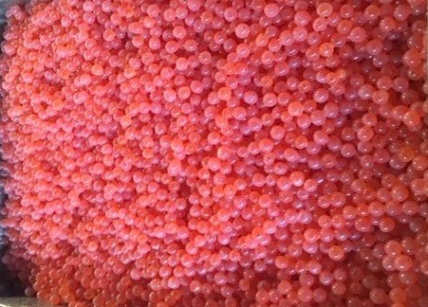

Evaluation of Bulk Incubation in Chilled Fog Incubator

By

REDD ZONE

January 19, 2018

Evaluation of Bulk Incubation in Chilled Fog Incubator
By
REDD ZONE, LLC
January 30, 2018

Lead Investigator: Tod A. Jones

Abstract

The use of one micron chilled fog to incubate salmon eggs during early incubation has been successfully demonstrated and is being employed in several hatcheries from Alaska to Northern California. (See unpublished report “Gnat Creek Trial”, March 15, 2015) Existing Chilled Fog incubators are deployed with twelve trays upon which fertilized, water-hardened eggs are placed at a depth of .75 inches. Protocols to remove the acidic by-products of respiration called for twice a week gentle rinse of the eggs beginning after a week of incubation. This trial seeks to determine if egg survival to the eyed stage could be accomplished with eggs three inches deep using rinsing protocols of three times per week and daily rinsing. If successful, this would allow the operator to handle fewer baskets compared to many trays. Two identical trials were run using two different stocks of Pacific Salmon in two separate hatcheries with two types of water for incubation and rinsing. One resulted in total loss of eggs prior to eyeing, while the other produced results above ninety percent survival.

Methods and Protocols

Two Chilled Fog incubators were deployed to two separate hatcheries equipped with baskets made of ABS plastic with three-inch sides and divider. Two baskets were used in each incubator, one to allow for the incubation of eggs three inches deep and one at .75 inches deep as a control. One incubator was set up in the incubation room of the Naselle Salmon Hatchery owned and operated by Washington Department of Fish and Wildlife and was populated with Coho salmon eggs. The second incubator was placed at the Noble Creek STEP hatchery, owned and operated by Coos River STEP of Charleston, Oregon under the observation of Oregon Department of Fish and Wildlife. This latter unit was populated with fall Chinook eggs deemed surplus to the needs of the hatchery. Operation of the Naselle unit was by WDFW hatchery staff and the Coos River STEP unit was operated by the volunteers that operate and maintain that facility. Both trials followed the same protocols: one half of the full basket was rinsed daily while the other half was rinsed three times a week. A separate basket with .75 inches of eggs were rinsed three time per week. Temperatures in each unit were set to mimic existing hatchery water supply. Both were 9C to 9.5C with minor adjustments. The Naselle unit operated on river water and rinsed with river water, which had a heavy load of organic solids. The Noble Creek unit was operated on spring water for both incubation and rinsing. Although no tests were run to evaluate the presence or absence of pathogens, this water supply was free from suspended solids. Both units were operated for six weeks until presence of a strong eye appeared then removed from their respective units and evaluated for total mortalities.

Results

The Naselle unit had developed massive clumps of fungus (saprolignia sp.) and the few live eggs that remained were very soft and would collapse upon handling. The control tray had been accidently spilled half way through the incubation cycle, however, it had also begun to show high mortality and likely would have resulted in the same outcome. This unit was declared a 100% loss. The Noble Creek unit had three different results. The control basket achieved 96.9% survival. The three-inch deep egg basket that was rinsed three time a week achieve 89.9% survival and the three-inch deep basket rinsed daily achieved 97.5% survival. (See attached photos of eggs prior to and after shocking and picking) The Noble Creek eggs were removed from the incubator, dumped on a flat surface and agitated then placed back into the incubator overnight. The following day all moribund eggs were removed and enumerated by volume to determine total losses.

Discussion

NASELLE

This trial used the same stock of Coho salmon that had previously been used in the Chilled Fog incubator at the Naselle Youth Camp on 3/4 inch trays using unfiltered surface water. The same results were seen where eggs became very soft and dissolved due to build-up of C02 byproducts. It seems clear that both incubation water and rinsing water need to be depurated or at least filtered to remove suspended solids that harbor fungal spores. The hatchery has domestic chlorinated water. A similar but smaller scale trial should be executed next year to see if de-chlorinated, pathogen free water will successfully incubate this stock of eggs. It should be pointed out that the 2015 Gnat Creek Trial was conducted with surface water with significant levels of suspended solids, however, in that trial the incubation and rinse water was filtered through a 5micron filter. No fungus developed in that trial.

Nobel Creek

This trial used a hatchery stock of fall Chinook that when gametes are taken they are transported to the Bandon Hatchery owned and operated by Oregon Department of Fish and Wildlife for eyeing. This trial kept the eggs at the Noble Creek facility. Both the Naselle and Noble Creek trials began egg rinsing the day following water hardening and loading to the baskets. It is the suspicion of this investigator that the protocol of waiting a week should be tried on a subsequent trial. This may reduce the mortalities experienced. A follow-up trial using small inserts on the baskets to reduce the number of eggs required to achieve results should be conducted comparing the immediate rinsing to delayed rinsing. This trial, however, confirmed that eggs can be fog incubated in depths up to three inches and rinsed daily can achieve acceptable survival rates and reduce the work required to load the incubator and in the rinsing protocols.

Acknowledgements

Redd Zone wishes to thank the staff at Naselle Salmon Hatchery for their support in allowing this trial to be conducted at their facility and for monitoring and logging daily temperatures plus performing the rinsing of eggs. We also extend the same thank you to the volunteers at the Noble Creek STEP hatchery for helping with all facets of the trial. They kept the equipment running in challenging situations, performed the rinsing protocols and logged the daily temperatures. Without their dedicated effort, this successful experiment could not have been conducted. A thank you also to the staff at Charleston ODFW that made it possible for the gametes to be available.

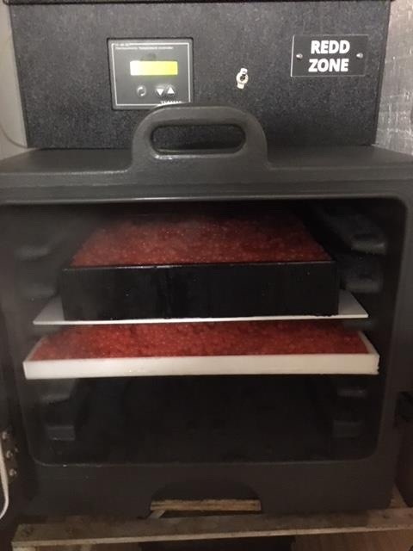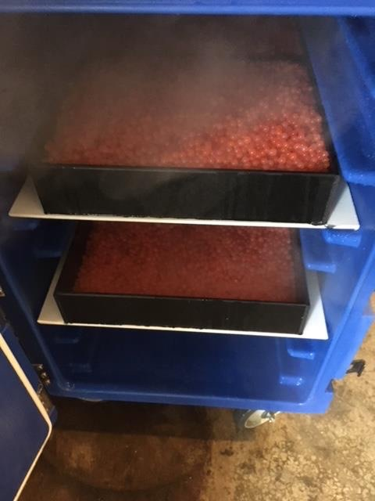
Naselle Coho Eggs in Fog Incubator Noble Creek Fall Chinook Eggs in Fog Incubator

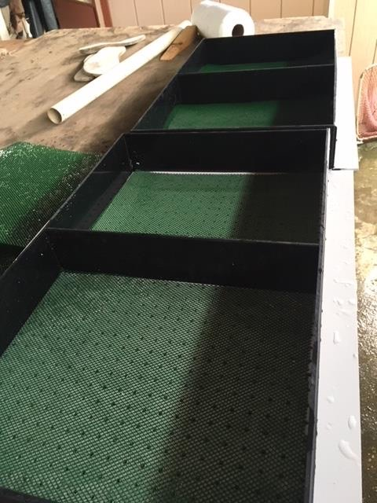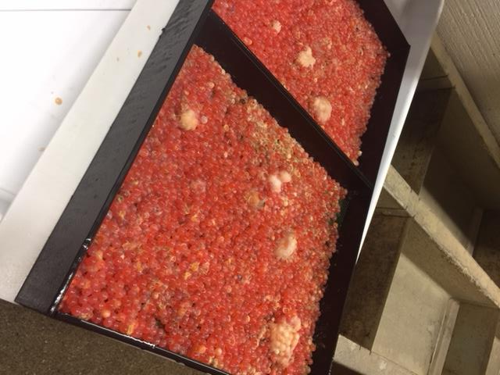
Egg Baskets prior to loading Naselle Coho Eggs after 550 TU

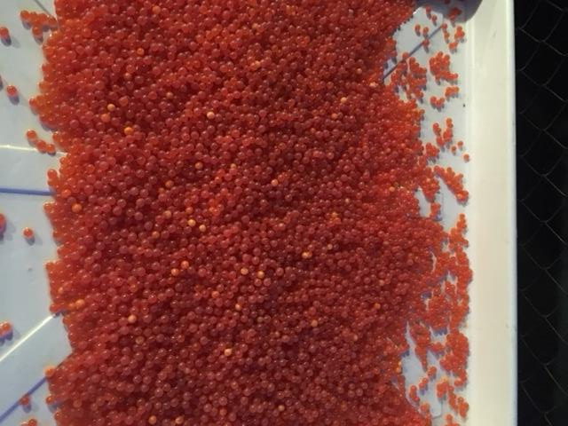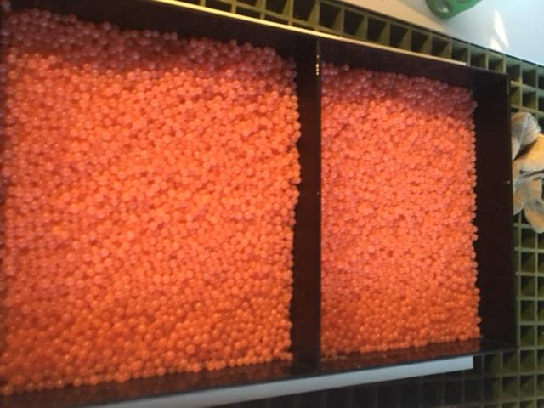
Noble Creek Eggs after 550 TU Control Eggs after picking

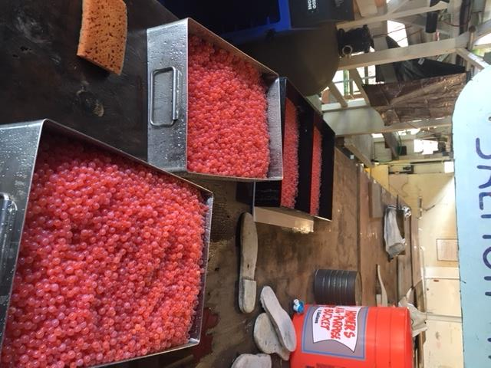
Noble Creek Fall Chinook after Picking

