PRODUCT REPORT

Ultraviolet Water Treatment Alternative to Chemical Treatment for Saprolignia, sp.
Tod Jones
Redd Zone, LLC

ABSTRACT
Early incubation of salmon and trout eggs most often requires regular and frequent prophylactic treatment for the growth of fungus (Saprolignia, sp) on moribund eggs, egg shells, and other detritus associated with the collection and fertilization of gametes. This trial was conducted to evaluate the efficacy of incubating well rinsed fertilized and iodophor water hardened eggs in pathogen free water without any chemical component. Gametes were secured from the Kalama Falls Fish Hatchery owned and operated by Washington Department of Fish and Wildlife in Kalama, Washington. A Portable Egg Eyeing Station made by Redd Zone, LLC was installed and operated with 100% recycled filtered river water, temperature controlled and UV filtered with a 57 Watt UV sterilizer until eggs were eyed. Eggs were evaluated by Redd Zone and hatchery staff as to how well the system prevented fungus from forming and clumping eggs. A comparable lot of eggs taken and incubated on the same water supply as a control using twice weekly treatment with formalin. The UV treated eggs had similar green to eyed survival and were very clean with no fungal clumping.

Methods
On December 15, 2021 the Kalama Falls Hatchery staff conducted their last egg take of Coho salmon. Once the hatchery goals were achieved the remaining fish were used to provide gametes for this study. Eggs from nineteen females were combined with sperm from a like number of males and provided to Redd Zone for the trial. Hatchery eggs were placed in upwelling eyeing boxes with raw river water used for eyeing. The remaining eggs and sperm were combined and given to Redd Zone. Water was drawn from the Portable Egg Eyeing Station that had been recycling for twenty-four hours. This pathogen free water was used to mix with the gametes to stimulate fertilization and to rinse off the majority of detritus at which point the eggs were placed in an iodophor bath for fifty minutes. Water hardened eggs were rinsed once more to remove all iodophor then placed into two incubators on the Egg Eyeing Station. Each incubator was estimated to have 38,000 eggs. Water temperature was maintained at 48F using a ½ hp chiller. Water was recycled through the chiller, UV Filter and the incubators then back into a reservoir. The returning water cascaded through a spray bar to dissipate CO2 and to re-oxygenate the water. O2 levels remained a constant 10.1 mgl throughout the incubation period. Once each day hatchery staff would allow four gallons of water to exit the system which was automatically replaced with four gallons of new water that had passed through a 10 micron filter. This eliminates the larger suspended solids without stopping the passage of fungal spores.

Once a week the eggs were examined with two sentinel dead eggs on the surface of the egg masses to observe if fungus was forming. At the end of the third week, (336 TU F) one sentinel egg began to show a slight growth of fungus. Eggs had a weak eye so it was decided to go one additional week before evaluation. At the end of week four (480 TU F) eggs were well eyed and the sentinel egg still showed minor fungal growth. Eggs were addled on January 14, 2022 and removed for picking on January 15, 2022. Eyed eggs were run through an optical egg picker and a sample of 500 eggs were weighed to determine total live eggs vs dead eggs by weight, a common protocol used in many hatcheries.

Results
Eggs were determined to be 1947 eggs per pound and total live eggs were 38.3 pounds for a total of 74,570 live eggs (95.5%) and 1.8 pounds or 3,504 dead eggs (4.5%). A very small number of eggs showed fungus growth and many of the moribund eggs were beginning to break down without fungal growth. Eggs were very clean with no clumping from fungus and easily worked through the egg sorter.

Discussion
Previous experiments with spring water and well water have been successfully incubated in the Redd Zone Portable Egg Eyeing Station without fungus growth but this trial was to challenge the efficacy of the UV treatment using surface water known to harbor a large load of suspended solids and hence fungal load. This method of incubating in recycled UV treated water appears to validate the notion that water bearing large quantities of fungal spores can be accomplished without the need for using harsh chemicals such as formalin or iodine.

Acknowledgements
Redd Zone would like to thank the staff at the Kalama Falls Fish Hatchery for their collaboration in this trial and their professionalism in all aspects of the endeavor; Shawn Collins, Adam Tymkowics, Andrew Brown, Brett Jungwirth, Ray Tremayne and Caitlynne Bishop.

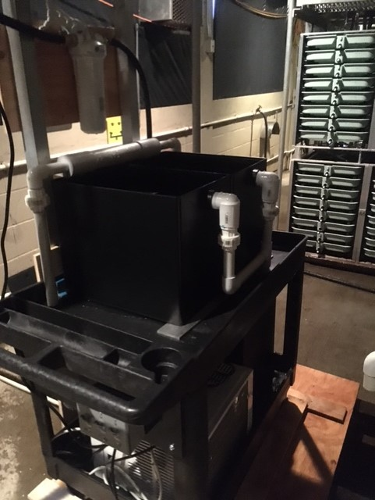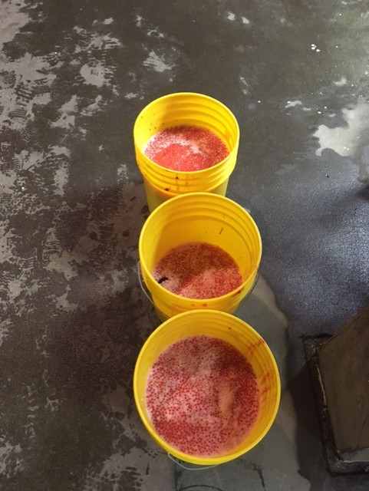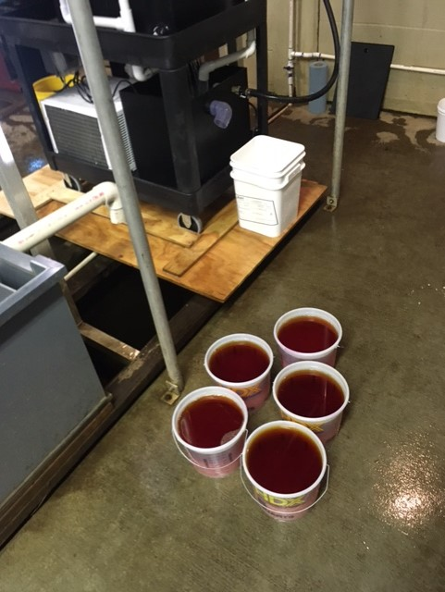
Portable Egg Eyeing Station Coho Gametes for Trial Fertilized Eggs in Iodophor

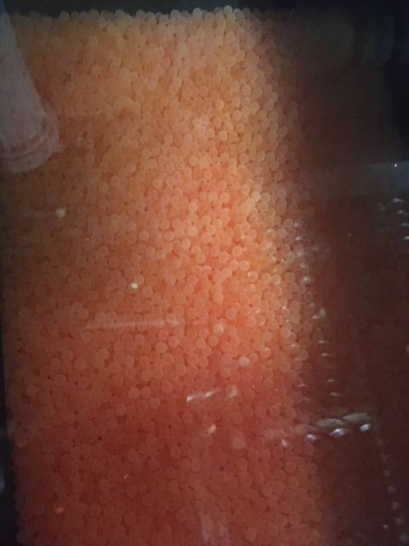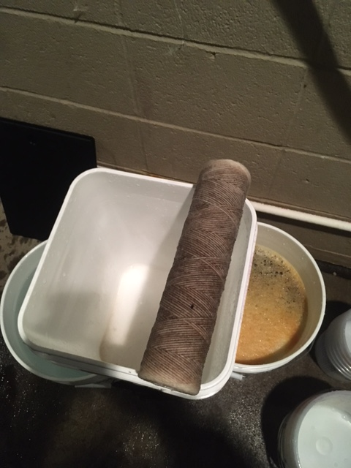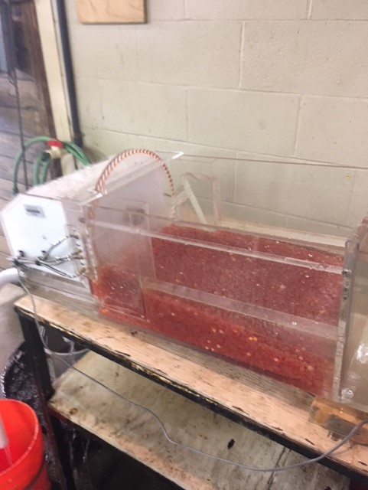
Eggs In Eyeing Station 12/15/21 10 micron filter seven days Sorting Eyed Eggs 01/15/22

